
Work Instruction for Pacemaker Cluster Configuration v2 App Server

Viatris
Work Instruction for Pacemaker Cluster Configuration v2 App Server

Contents
Contents 2
1. Introduction 3
1.1. Purpose 3
1.2. Scope of this Report 3
1.3. Audience 3
1.4. Definitions 3
2. Approach and Methodology 3
2.1. Approach 3
2.2. Methodology 3
3. Technical Details 4
3.1. Cluster Configuration 4
3.2. Configuration 5
3.3. Configuration 11
4. Roles and Responsibilities 17
5. Escalation Matrix 18
6. Related Documentation 18
6.1. Additional Documentation 18
7. Revision History 18

1. Introduction

1.1. Purpose
The objective of this document is to define Pacemaker Cluster configuration of App Server.

1.2. Scope of this Report
The purpose of this guide is to provide details on Pacemaker Cluster configuration of App Server.

1.3. Audience
GIDC Unix Group

1.4. Definitions
- Term: Definition
- Term: Definition

2. Approach and Methodology

2.1. Approach

2.2. Methodology

3. Technical Details

3.1. Cluster Configuration
Requirement:
No of Participation Node: 2
Float Resources:
- VIP
- Mount point: /usr/sap/RP1/ASCS00
- ASCS service (Custom Script)
- Fencing device
Application Architecture:
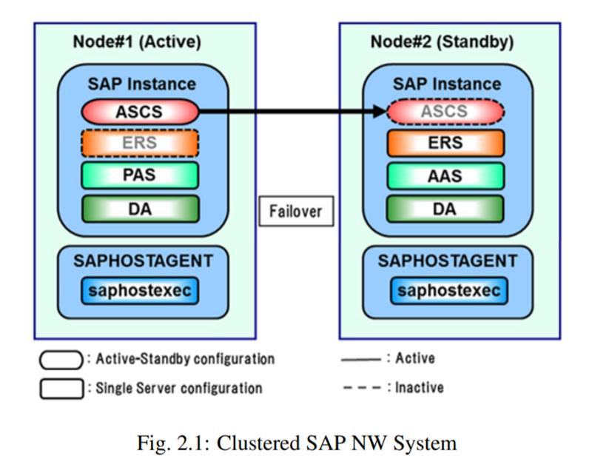

3.2. Configuration:
    - VMware Configuration:
3.2.1.1 Both servers are located in individual Esxi host to achieve Host level redundancy.
        - Add affinity rule to keep the VMs running in different host at the Vmware cluster. (refer MYL-UNX-SOP-VMARP- 001).
      - Disable DRS automation level to Manual (Refer SOP)
      - Snapshot backup need to disable for both the VMs.
      - Both VMs should use individual data store
      - Both VMs should have same amount of CPU and Memory allocation.
      - Shared storage for cluster mount point should meet following:
        - Eagerly zeroed and independent and persistent disk
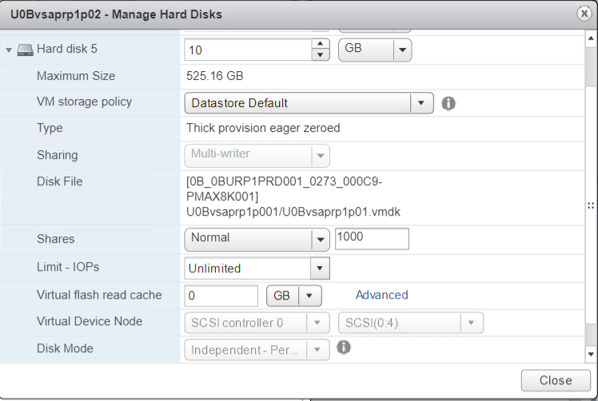
        - Multi-writer sharing mode
      - Both the VMs should be added in the VM folder “Unix RP1-osfence”. So that service account should have access to the VM.
Note: Service account having below privilege:
- System.Anonymous
- System.View
- VirtualMachine.Interact.PowerOff
- VirtualMachine.Interact.PowerOn

3.2.2 OS level Configuration:
3.2.2.1 Both servers should deploy from Mylan Approved template and required pre-requisites should meet based on the application requirement.
      - Both the node configured with required mount points.
      - Cluster mount point should be created at one server and rescan at another server.
      - Disable IPv6 addressing in both server.
      - Both server should be Subscribe with Redhat enterprise Linux license and resilient storage License, Then enable HA repos mentioned below.
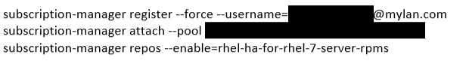
      - Install Cluster packages and fencing agents by,
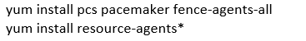
      - Reset password of hacluster user in both node with same password and save it in CyberArk password vault.

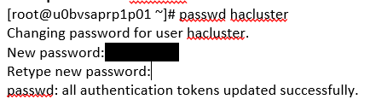
      - Make host entry in /etc/host file n both node

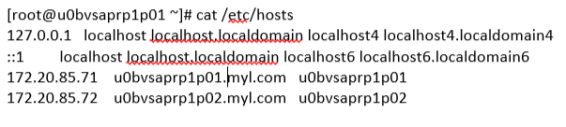
      - Make sure that pcs daemon is running on both node from server bootup
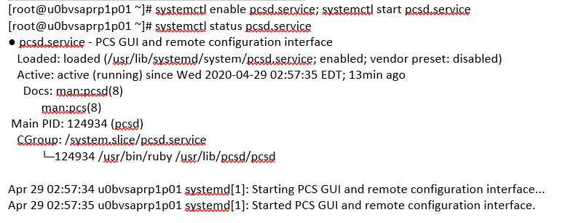
      - Authenticate both cluster node in PCS

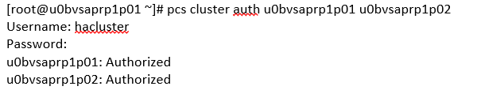

      - Create a cluster and populate it with both nodes. Note that the name cannot exceed 15 characters.

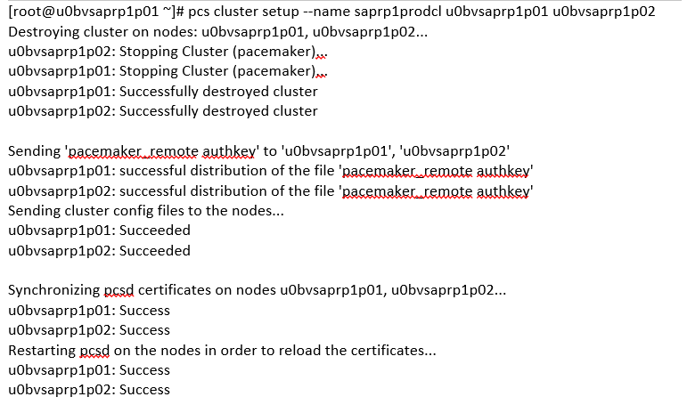

      - Start the cluster services in both node now and system bootup.
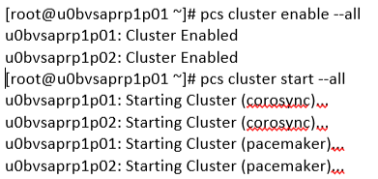

      - Validate the cluster Status.

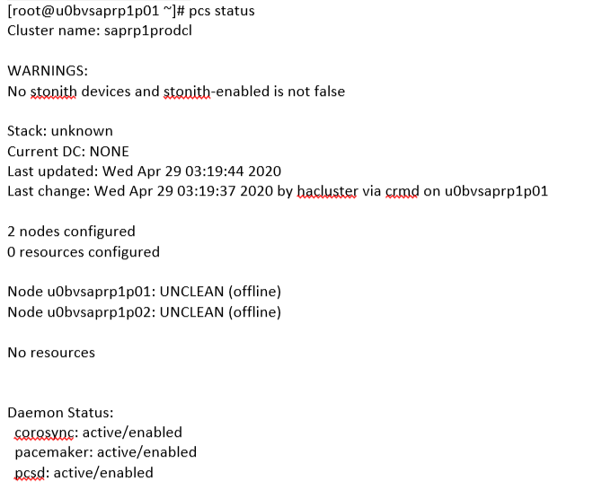

      - At this point Cluster was created and resources are not added.

    - Fencing Configuration:
      - Manually verify that the fence agent is able to communicate with the fence device.
      - Manually fence the Cluster node and validate service account having privilege to fence the node.
      - Create STONITH Device and add it into the cluster resource by,

      - Tuning: (Optional)
      - If stonith device having failure, replace the hostname with IP address of Vcenter.
# pcs stonith update fence0_rp1p ipaddr=172.20.21.109
      - If stonith device having Timeout error frequently, Increase the timeout value
# pcs stonith update fence0_rp1p power_wait=5 power_timeout=30 shell_timeout=10 login_timeout=10 retry_on=3
# pcs stonith update fence0_rp1p op monitor timeout=90s

    - VIP configuration:

      - Configure the VIP or Floating IP in Cluster:
        - Floating IP – It should be production or end user communication IP address.
        - VLAN of the floating IP was configured at Both Node NIC
        - Better to choose same VLAN as persistent IP
        - Add the IP which needs to be high-available to the cluster,

      - Configure the VIP or Floting IP in Cluster:
        - Floating IP – It should be production or end user communication IP address.
        - VLAN of the floating IP was configured at Both Node NIC
3.2.4.2.3 Better to choose same VLAN as persistent IP.
Check the Resource status
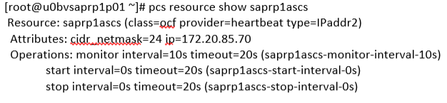

3.3. Configuration
3.3.1 Filesystem Configuration:
Refer attachment for RHEL 8 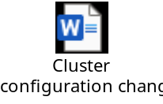
      - Create a PV and VG and LV in any one of the node and rescan at another node.

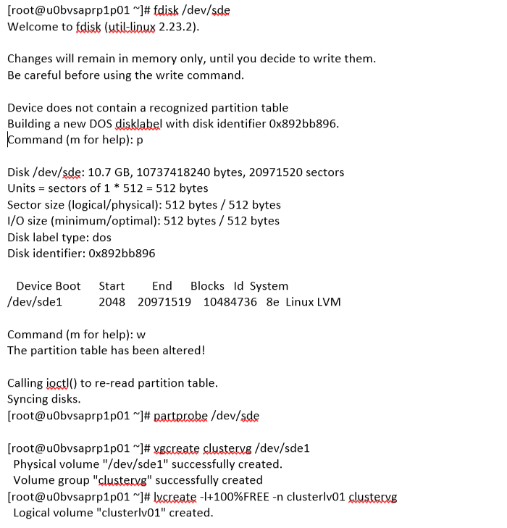
      - Modify LVM configuration at both Node:
      - Backup the /etc/lvm/lvm.conf file.
      - Make sure that “use_lvmetad” parameter is set to “0” in both node. This is mandatory when you use “Pacemaker”.
      - To prevent the automatic volume group activation, update the volume_list parameter with local VG’s which needs to be activated automatically.
      - Rebuild the “initramfs” boot image to guarantee that the boot image will not try to activate a volume group controlled by the cluster. Update the initramfs device using the following command.

      - Reboot the nodes.
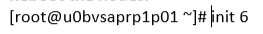
      - Configure the VG into Cluster by
      - Check the resource status:
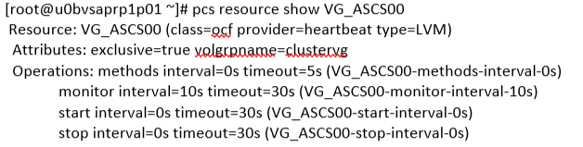
      - Configure FS into Cluster by,
      - Check the resource status:
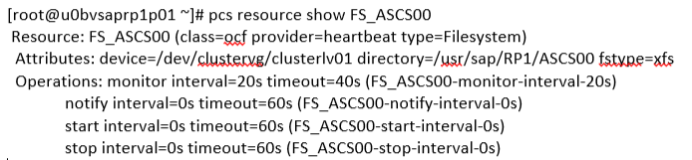
    - Application Configuration:
3.3.2.1 Once Infra ready, handover the cluster setup to basis team to configure Application service on both Node.
Configure Application startup and start script in Cluster:
      - SAP will provide application start, stop and validation command to configure it in cluster.
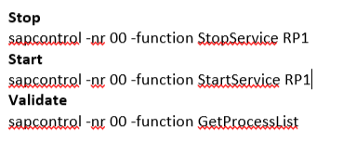

      - Create start and stop script from given Application command
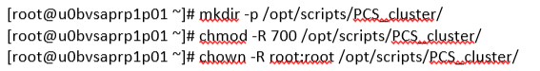
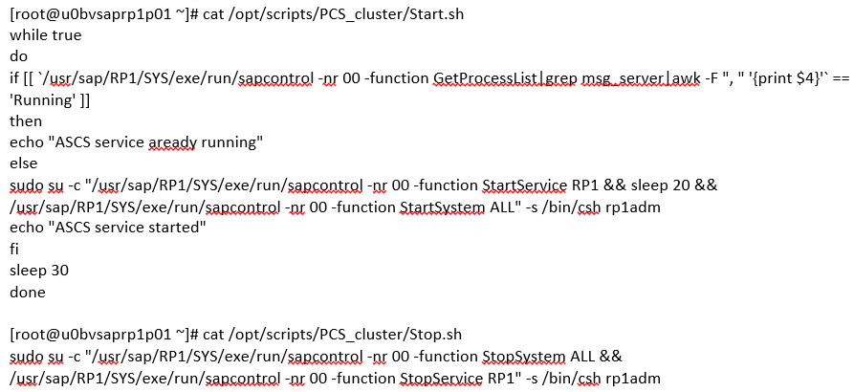
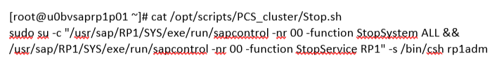
      - Create the Application service at OS level with stop and start script and reload systemctl daemon

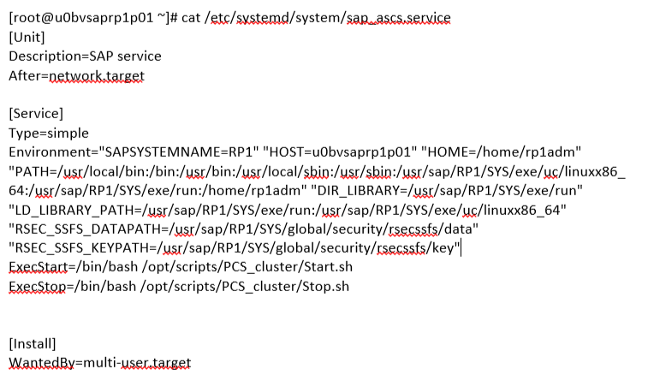
      - Test application service at OS level.
      - Add the application service in Cluster
    - Resource constraint configuration:
3.3.3.1 Configure order and colocation constraint for cluster resources based on sequential.
        - saprp1ascs
        - VG_ASCS00
        - FS_ASCS00
        - ASCS_RP1

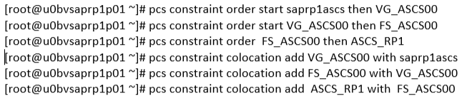
To check the constraint status,
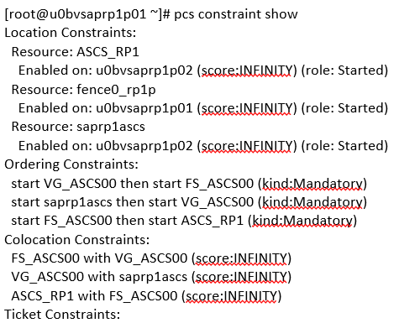
Check the cluster status
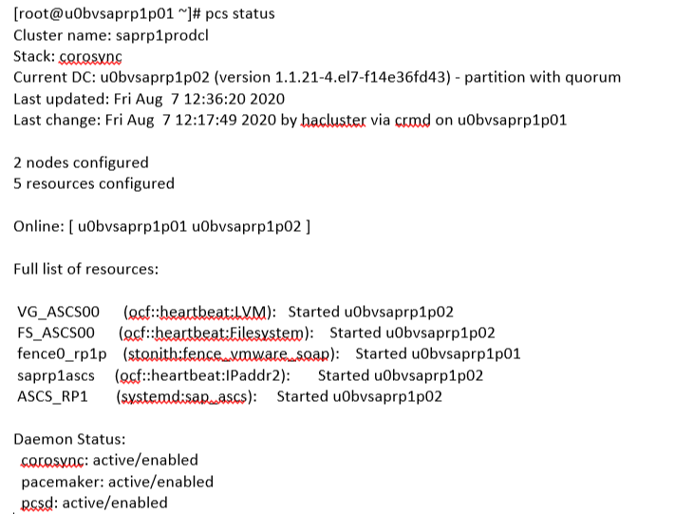
3.3.4 Alert Configuration:
Configure the cluster alert to Zenoss Monitoring SMTP probe By,
# install --mode=0755 /usr/share/pacemaker/alerts/alert_smtp.sh.sample /var/lib/pacemaker/alert_smtp.sh
# pcs alert create id=smtp_alert path=/var/lib/pacemaker/alert_smtp.sh options email_sender=cluster_sapgepclst@myl.com
# pcs alert recipient add smtp_alert =netcoolemailmonitoring_dev@myl.onmicrosoft.com

4. Roles and Responsibilities
Sl. No. | Roles | Responsibilities | Team Member Name
1. | Maintenance Window | Respective Team / Unix Team | GIDC.unix_Run  GIDC.unix_Run@viatris.com
2. | Change Request | Respective Team / Unix Team | GIDC.unix_Run  GIDC.unix_Run@viatris.com
3. | Change Implementation | Respective Team / Unix Team | GIDC.unix_Run  GIDC.unix_Run@viatris.com
4. | Hyper Care | Respective Team / Unix Team | GIDC.unix_Run  GIDC.unix_Run@viatris.com

5. Escalation Matrix
Person Responsible | Role | Triggers When
Arun R  Arun.R@viatris.com  +91 9710677240 | SME
Ashok Kumar R K  AshokKumar.RK@viatris.com  +91 9967735890 | Manager
Mohandoss Murugesan  Mohandoss.Murugesan@viatris.com  +91 6366966170 | Senior Manager

6. Related Documentation

6.1. Additional Documentation

7. Revision History
Date | Version | Summary of Changes | Author | Approved by
May 19 2021 | V1.0 | Updated Organization Detail | Franklin Kabila Dhas | Arunachalam G
Apr 5 2023 | V1.1 | Updated in New Template | Ashok Kumar RK | Mohandoss Murugesan
Dec 28 2024 | V1.2 | Validated the Document | Benesh Selva Nesan P | Arun R

